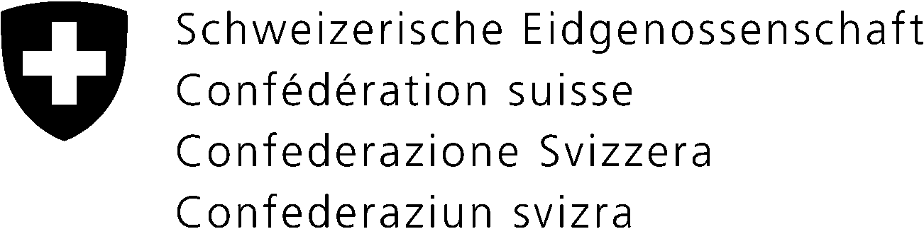 | EMBASSY OF SWITZERLAND IN VIETNAM
 | To whom it may concern
Our reference: 771.13
Phone: (+84) 4 3934 65 89
Fax: (+84) 4 3934 65 91

Hanoi, August 2014

Swiss Government Excellence Scholarship for Foreign Scholars for the Academic year 2015/2016

Dear Sir/Madam,

The Embassy of Switzerland in Hanoi has the pleasure to announce that, through the Federal Commission for Scholarships for Foreign Students (FCS), the Swiss government will be granting Swiss Government Excellence Scholarships for foreign scholars.

The Swiss Embassy refers to the enclosed:
- Application Guidelines
- 2015-2016 Application Form
- Project Proposal Form
- Recommendation Letter form
- Medical Certificate Form and informs as follows:

There are 3 scholarships types:
- PhD scholarships
- Postdoctoral scholarships
- Research scholarships

Applications have to be sent in 3 hard copies to the Swiss Embassy within the deadline (date indication at the end of this letter).

Every application must include the following 8 documents in the given order:

- The official 2015-2016 Application form (typed and printed). No handwritten form will be accepted
- Curriculum vitae
- Motivation letter
- The official Research Proposal (max. 5 pages) including a timeframe (this is the central piece of the application) and
- Copy of the confirmation from a Professor at the intended Swiss University that he/she will supervise the research
- 2 confidential Letters of Reference of 2 professors (use only the official forms)
- Photocopies of Certificates from previously attended universities/colleges and diplomas with grades
- Medical Certificate form (use only the official form)
- Copy of passport (page with personal data)

Applicants:
- must apply for only 1 University. Applicants who have applied for 2 or more Swiss Universities will not be taken into consideration by the Swiss Embassy.
- must apply to the chosen Swiss University as well as for the scholarship. The two procedures are separate and must be simultaneously undertaken (application deadlines must be respected)
- should not be more than 35 years old at the moment of the application
- should be residing in their home country at the moment of the application, applicants who are in Switzerland since more than 1 year are not eligible
- who have already benefited from a Swiss Government scholarship are not eligible for a second scholarship
- must be in command of the necessary language skills required for the studies

Applications which are incomplete or poorly prepared cannot be considered!

Deadline: The application package must be sent or handed in until November 15, 2014 at:
Embassy of Switzerland, 15th Fl., Hanoi Central Office Building, 44B Ly Thuong Kiet Str, Hanoi

Warning against fake scholarship offers using the name of
the Swiss Government Scholarships
The FCS never advertises its scholarships by e-mail. The scholarships are directly managed by the Swiss Embassy in Hanoi who recommends to never answer to these e-mails and above all not to send any money.

Information about the Swiss Government Scholarship, studying in Switzerland and about Swiss Universities can be found at:

http://www.sbfi.admin.ch/themen/01366/01380/02175/02367/index.html?lang=en

For further questions please contact the following e-mail: han.vertretung@eda.admin.ch

Yours sincerely,

For the Ambassador of Switzerland

Monika Huber
Enclosures:
- Application Guidelines
- 2015-2016 Application Form
- Project Proposal Form
- Recommendation Letter Form
- Medical Certificate Form

